**ABSTRACT**

Crowdfunding is the most popular way for raising money for any cause, startup or to help someone. Traditional crowdfunding platforms are less secure and there is no transparency how the raised amount is being utilised. a blockchain-based crowdfunding web app aims to increase contributors' trust by providing more transparency and security to the funding process. Money will not be donated directly

to the campaign creator's account instead it will be kept in the smart contract account when the campaign creator wants to withdraw money from the smart contract they have to inform contributors where they are going to use the money and make withdrawal request when more than 50% contributors approve their withdrawal request then only they will be able to withdraw to money from the smart contract.

This method of raising funds will increase contributors' trust in crowdfunding and establish healthy relationships between contributors and fundraisers.

# ACKNOWLEDGEMENT

I would like to express our special thanks of gratitude to our teacher **Mrs. Shivannya Kadam** who gave me the golden opportunity to do this wonderful project on the topic **Funding Prism**, which also helped us in doing a lot of Research and we came to know about so many new things we are really thankful to her. Secondly I would also like to thank my parents who helped me a lot in finalising this project within the limited time frame.

I would like to express my heartfelt gratitude and appreciation to all those who have contributed to the successful completion of my final year project, titled "Blockchain-Based Crowdfunding Platform." This project aimed to develop a platform that utilizes blockchain technology to revolutionize the crowdfunding process and enhance trust, transparency, and security for both project creators and backers.

First and foremost, I would like to thank my project supervisor **Mr. Dhanraj Jadhav** for their invaluable guidance, support, and expertise throughout the entire duration of this project. Their insightful feedback, encouragement, and commitment to excellence have been instrumental in shaping the project's direction and ensuring its successful completion. I am truly grateful for their mentorship and the valuable lessons I have learned under their supervision.

I would also like to extend my sincere appreciation to the faculty members of **Sathaye College** whose dedication to education and commitment to fostering an environment of learning have been crucial in shaping my academic journey. Their knowledge, expertise, and willingness to assist whenever needed have significantly contributed to the development and execution of this project.

Furthermore, I would like to acknowledge the support and cooperation received from my fellow classmates and friends who have provided assistance, insightful discussions, and encouragement throughout this project. Their input and collaborative efforts have helped me to overcome challenges and enhance the overall quality of the final product.

I am deeply grateful to the developers and contributors of open-source blockchain frameworks and technologies, whose extensive work and documentation have provided the foundation for this project. Their commitment to advancing the field of blockchain technology and making it accessible to developers worldwide has been truly inspiring.

Finally, I would like to express my heartfelt gratitude to my family and loved ones for their unwavering support, patience, and understanding throughout this challenging yet fulfilling Finally, I would like to express my heartfelt gratitude to my family and loved ones for their unwavering support, patience, and understanding throughout this challenging yet fulfilling journey. Their constant encouragement, belief in my abilities, and unconditional love have been the driving force behind my accomplishments.

**TABLE OF CONTENTS**

|  |  |  |  |
| --- | --- | --- | --- |
| **Sr. No** |  | **Contents** | **Pg. No** |
| **01** |  | **Introduction** | **1-3** |
|  | **1.1** | **Background** | **1** |
|  | **1.2** | **Objective** | **2** |
|  | **1.3** | **Purpose** | **2** |
|  | **1.4** | **Scope** | **2-3** |
|  | **1.5** | **Applicability** | **3** |
| **02** |  | **Review of Literature** | **4-10** |
| **03** |  | **Methodology/Approach** | **11-18** |
|  | **3.1** | **Problem Definition** | **11** |
|  | **3.2** | **Requirement Specification** | **11-12** |
|  | 3.2.1 | Functional Requirements | 12 |
|  | 3.2.2 | Non Functional Requirements | 12 |
|  | **3.3** | **Software Requirements** | **12-13** |
|  | **3.4** | **Hardware Requirements** | **13** |
|  | **3.5** | **Planning Schedule** | **14-15** |
|  | 3.5.1 | Schedule Table | 14 |
|  | 3.5.2 | Gantt Chart | 14 |
|  | 3.5.2 | Pert Chart | 15 |
|  | **3.6** | **Preliminary Product Description** | **16** |

|  |  |  |  |
| --- | --- | --- | --- |
|  | **3.6** | **Preliminary Product Description** | **16** |
|  | **3.7** | **Methodology** | **16-17** |
|  | **3.8** | **Conceptual Model** | **18** |
| **04** |  | **UI Design** | **19-** |
|  | **4.1** | **Flow of creating and contributing to campaigns** | **19** |
|  | **4.2** | **ER Diagram** | **20** |
|  | **4.3** | **Data Design** | **20** |
|  | **4.4** | **Use Case Diagram** | **21** |
|  | **4.5** | **Class Diagram** | **22** |
|  | **4.6** | **Data Flow Diagram** | **23** |
|  | 4.6.1 | Level 0 DFD | 23 |
|  | 4.6.2 | Level 1 DFD | 23 |
|  | 4.6.3 | Level 2 DFD | 24 |
|  | **4.7** | **Wireframes** | **25-27** |
|  | 4.7.1 | Home Page | 25 |
|  | 4.7.2 | Campaigns Page | 25 |
|  | 4.7.3 | After clicking on any campaigns | 26 |
|  | 4.7.4 | After clicking on view withdrawal request | 26 |
|  | 4.7.5 | After clicking on create withdrawal request | 27 |
|  | 4.7.6 | After clicking on view withdrawal request | 27 |



**Chapter 1 : Introduction**

Crowdfunding has emerged as a transformative and innovative method for financing a wide range of ventures. Through crowdfunding, individual project creators can present their funding requests, providing a unique and creative approach to securing financial support for their initiatives. These initiatives encompass diverse objectives, spanning financial, cultural, or social realms. To effectively generate funds for these initiatives, online social media platforms have become integral in connecting investors and entrepreneurs, creating new pathways for fundraising and community engagement.

The advent of social media and the internet has played a pivotal role in revolutionizing the landscape of fundraising, particularly for nonprofit businesses and entrepreneurs. Leveraging these platforms, crowdfunding campaigns can reach a broader audience, tapping into a global network of potential supporters. This widespread access to information and connectivity has opened up unparalleled opportunities for fundraising and project promotion.

We can integrate blockchain technology into crowdfunding to further revolutionize the crowdfunding process, offering substantial benefits to both crowdfunding organizations and individual project creators. Blockchain-based crowdfunding platforms harness the power of decentralized networks and cryptographic protocols, introducing transparency, security, and trust into the fundraising process. As a result, these platforms elevate the credibility of initiatives and endeavors, attracting significant financing from investors and contributors.

Traditional crowdfunding platforms have limitations in terms of transparency, trust, and accountability. However, blockchain technology addresses these challenges by providing immutable records, enhanced security, and decentralized consensus. This has significantly raised the credibility of various crowdfunding campaigns, attracting a massive influx of financing from investors and contributors.

**1.1 Background**

Many tactics have been used by the government to handle government finances in order to combat the Covid-19 disease epidemic in the current circumstances. The community also decided to gather money in response to this circumstance to aid the government in combating the Covid-19 plague outbreak. In the process of raising funds, of course it is not easy, because it requires trust between many parties, both the funders, intermediaries or organisations as a place to store temporary funds to the recipient of funds.

That trust is the main capital for fundraising organisations to attract funders to donate their funds to recipients of funds. Numerous nonprofit organisations participate in fundraising efforts, particularly in light of the Covid-19 pandemic. Gaining contributors' trust is their biggest obstacle to raising money for the organisation. a nonprofit organisation that uses technology to simplify the process of receiving donations from donors.

Therefore, it can be inferred from this that technology also plays a significant part in obtaining as much funds as possible, in addition to trust, which is the key component. By integrating blockchain technology with crowdfunding platforms, we can boost funders' confidence, which will undoubtedly have an impact on the amount of money that fundraising organisations will be able to raise.

**1.2 Objective**

Focus of this project is to create an Ethereum blockchain based decentralised crowd funding application to bring trustability, transparency and security to the fund raising process by eliminating all the limitations of traditional crowdfunding platforms.

Main objectives are:

1. To increase contributors' trust in the crowdfunding process.
2. To provide transparency on how money is being used.
3. To keep record of all the transactions over the blockchain ledger.
4. To improve security as the fund becomes larger it requires greater security.
5. To enable global contribution.

**1.3** **Purpose**

The most prevalent method of money collection is fundraising. Many organisations are gathering money to aid people and the government for the distribution of money to the people in need during the most critical times of COVID-19 and other natural calamities. Even for brand-new businesses, money is raised. Trust and security are crucial for those who are active in fund-raising. We might encounter numerous problems with trust and a lack of transaction transparency while using the traditional way of fund-raising.

Anyone who has access to the donated funds can readily engage in malicious activities. In order to address this issue, our project will offer greater security and transparency in an effort to win over additional contributors. To guarantee that the money is received by an authorised organiser, each transaction is recorded in the blockchain network. If all requirements are satisfied, beneficiaries can easily get these payments thanks to smart contract technology. Blockchain technology and smart contracts are used to construct this project's fundraising platform.

**1.4** **Scope**

The Blockchain based crowdfunding project aimed at developing an online crowdfunding platform which can be used for raising funds for charity, business and startups.

It is developed to simplify the operational and managerial task as well as improve the trust of contributors. Also helps fundraising organisations develop healthy relationships by providing transparency as everyone shares the same public ledger where all the transactions are recorded. The system provides startups a platform where they can pitch their ideas and people who find those ideas revolutionary can donate. Fundraisers can only withdraw money when more than 50% contributors give a positive response on their withdrawal request.

**1.5** **Applicability**

The flexibility and effectiveness of few well-known crowdfunding platforms, including Kickstarter and Indiegogo, have revolutionised the startup industry. The development of crowdfunding platforms using blockchain technology may be the next step in the revolution of crowdfunding platforms.

The main problems with these well-known crowdfunding platforms are that they are centralised organisations under the control of a company that charges hefty fees and manipulates campaigns. This approach can be aided by blockchain-based crowdfunding platforms that decentralise the fundraising paradigm used by organisations like Kickstarter and others.

The distributed ledger of the blockchain assists in eliminating centralised intermediaries like Kickstarter and Indiegogo that take significant sums of money from campaigns as maintenance fees. Blockchain crowdfunding is a more pure form of the practice because it does not use any middlemen to connect backers and startups.

Creators can post their campaigns on crowdfunding dapps and then ask a community of potential donors for money. Additionally, blockchain eliminates the influence and manipulation practised by centralised crowdfunding sites that have greater access than necessary to the campaigns that are being conducted on their platform.

**Chapter 2 :** **Review of Literature**

**Case Study 1**

**Title:** Crowdfunding Platform Using Blockchain Technology

**Research by:** Dr. R. Senthamil Selvi1, Surya Prakash, Vishnu, Priyadharsan, PrasannaVenkateswara

**Reference:** <https://ijirt.org/master/publishedpaper/IJIRT155716_PAPER.pdf>

**Review on Case Study 1**

The most popular strategy for obtaining money for various social problems and endeavours has been fundraising. The issues and difficulties with traditional fundraising require consideration. The benefits of blockchain have produced smart contract technology as well as a safe channel for funder and campaigner communication.Decentralisation is provided through blockchain.

The smart contract will not be under the control of any one member of the network. No one in the peer-to-peer network can change the data on the blockchain, making the crowdfunding process secure, safe, and transparent because it is a peer-to-peer network. On the Internet, anyone with a need can post their information. Anyone who wishes to help may do so as required. Following verification, every transaction is added to the blockchain network.

The blockchain concept is used to manage all transactions, and all transactions are documented. The amount is stored in blocks that make up a blockchain, so a third party is not required. As in the case of crowdfunding in the traditional sense, the backer does not have to worry about the money being transferred to an authorised fundraiser.

**Case Study 2**

**Title:** Blockchain Based Smart Contract: Comprehensive Study

**Research by:** *1Research Student, Department of Computer Science, Jagan Institute of Management Studies, Sector-5, Rohini, Delhi, India. *2 Associate Professor, Department of IT, Jagan Institute of Management Studies, Sector-5 Rohini, Delhi, India.

**Reference:** https://www.irjmets.com/uploadedfiles/paper/volume3/issue_5_may_2021/9847/1628083394.pdf

**Review on Case Study 2**

A peer-to-peer, decentralised, distributed, and continuously increasing immutable ledger made up of a linked chain of records is known as a blockchain. The records individually are referred to as events or transactions, while the sets of records collectively are referred to as blocks. A smart contract deployed on a blockchain network is comparable to a legal bond.

An agreement between two untrusted parties can be facilitated and carried out through the use of a smart contract, which is self-executing and self-enforcing code that runs on the blockchain. A further application of distributed ledger technology is smart contracts. Smart contracts serve as decentralised programmes on the blockchain network.

The program is immutable, and its immutability has been cryptographically validated to ensure the program's trustworthiness. The execution of smart contracts in peer-to-peer mode without the presence of a centralised third party and service availability without any centralised dependence are two of their most important features.

**Case Study 3**

**Title:** Blockchain Technology, Bitcoin, and Ethereum: A Brief Overview

**Research by:** Dejan Vujičić, Dijana Jagodić, Siniša Ranđić Faculty of Technical Sciences in Čačak University of Kragujevac Čačak, Serbia

**Reference:** <https://www.researchgate.net/publication/324791073_Blockchain_technology_bitcoin_and_Ethereum_A_brief_overview>

**Review on Case Study 3**

Bitcoin is a type of virtual currency known as a cryptocurrency that was created to serve as money and a means of payment independent of any single person, group, or entity, eliminating the need for third parties to get involved in financial transactions. It is available for purchase on numerous platforms and is given to blockchain miners as compensation for their efforts in verifying transactions. By utilising the pseudonym Satoshi Nakamoto, an unidentified developer or group of developers presented Bitcoin to the general public in 2009. Ethereum is a blockchain with a Turing Complete programming language integrated into it. It offers an abstract layer that enables anyone to develop their own standards for ownership, transaction formats, and state transition procedures. Smart contracts, a collection of cryptographic rules that only take effect when specific requirements are met, are used to achieve this.

**Case Study 4**

**Title:** Blockchain-Based Crowdfunding: A ‘Pay-itForward’ Model of WHIRL

**Research by:** Dejan Vujičić, Dijana Jagodić, Siniša Ranđić Faculty of Technical Sciences in Čačak University of Kragujevac Čačak, Serbia

**Reference:** https://whirl.com/WHIRL_WP.pdf

**Review on Case Study 4**

Crowdfunding has revolutionised the way of raising funds for not only start-ups but for all traditional or existing businesses. Crowdfunding made it easy for fundraisers to raise funds as they don’t have to knock on doors of banks and financiers and get the desired amount in return of interest or offering equity or even through donation, or reward. Blockchain, on the hand, is decentralising the system of records and control which makes crowdfunding more transparent and secure. Though a number of blockchain-based crowdfunding platforms are already doing good business and they vary in crypto, model and type of crowdfunding. The study is conducted on a very new blockchain-based crowdfunding platform, WHIRL. The unique and different in this model is the model, “pay-it-forward” itself. The model assures that members will get their legit project funded after they help other projects succeed. The study also highlights some thoughts from the Executive Board of Directors and co-founders after doing a brief discussion with them.

**Case Study 5**

**Title:** Decentralised application for crowdfunding using blockchain technology

**Research by:** H.L. Gururaj, V. Janhavi, Abhishek M. Holla, Ashwin A. Kumar and R. Bhumika

**Reference:** http://www.inderscience.com/storage/f256410837911121.pdf

**Review on Case Study 5**

Crowdfunding is a way for people, businesses, and charities to raise money. It works through individuals or organisations who invest in (or donate to) crowdfunding projects in return for a potential profit or reward. Investing this way can be risky. Security is the main challenging issue in crowdfunding contracts. Using existing literature on crowdfunding and blockchain technology, they put forward a conceptual framework that can provide the solution to the problems related to crowdfunding contracts using blockchain technology. This methodology points out the potential of crowdfunding decentralised applications to lower market inefficiencies by bypassing third parties and easing trades on secondary markets. This platform eliminates the interference of the middlemen. It is highly transparent and secure. A decentralised approach to crowdfunding forfeits all fees for the investor. It also gives a share of the project to the receiver. This model establishes a flexible platform for the fundraiser to start a campaign. The funders invest the amount if they feel the project to be genuine. Once 50% of the funds are received, it will be transferred to the initiator. It establishes a peer-to-peer relationship between the investor and the receiver.

**Literature Review**

[H.L. Gururaj et al. (2021)](http://www.inderscience.com/storage/f256410837911121.pdf) addressed the earlier work that had been done in the field of crowdfunding. Crowdfunding is the most well-liked method of project financing in the modern world. A person or organisation might present the concept for their initiative. Additionally, those who believe this notion is legitimate will invest (Tomczak and Brem, 2013). However, the internet has increased accessibility to crowdsourcing. The first-ever crowdsourcing website, called "Artistshare," became live in 2003. Since then, a number of crowdfunding websites, including Indiegogo, Kickstarter, RocketHub, and Gofundme, have launched. Nowadays, one of the hottest sectors is crowdfunding (Chen, 2018). Crowdfunding comes in a variety of forms, including reward-based, donation-based, equity-based, and lending-based.

[Dr. R. Senthamil Selvi et al. (2019)](https://ijirt.org/master/publishedpaper/IJIRT155716_PAPER.pdf) describe how blockchain technology might make crowdfunding safer and more transparent. Blockchain was initially primarily utilised as the basis for cryptocurrencies, but it has since developed into a brand-new, rapidly-emerging technology that is being employed in a variety of industries. Blockchain is anticipated to be included into the majority of technologies as an effective way to conduct online transactions in the future. The problem with today's crowdfunding model is that contributors and third-party middlemen have no control over the money they provide. This study introduces a blockchain-based crowdfunding network that, by utilising Ethereum smart contracts, may offer a private, secure, and decentralised crowdfunding path.

The main objective is to make it possible for donors to make effective contributions to any campaign anywhere in the world by using Ethereum and developing smart contracts that give donors control over the Ethereum they spend. This will also make it possible for campaign creators and donors to make and reserve financing for their project or campaign. The goal is to apply Ethereum smart contracts to the crowdfunding platform in order to fully automate the execution of the contracts, thereby resolving these issues and fostering positive relationships between the platform, the fundraisers, and the contributors.

[Baber (2019)](https://whirl.com/WHIRL_WP.pdf) came up with WHIRL, a blockchain-based platform for crowdsourcing. A pay-it-forward economic concept, which is at the foundation of WHIRL, aims to create a positive feedback loop of kindness and giving. By using the "pay it forward" approach, everyone who starts a campaign is guaranteed to have made their dues. WHIRL clearly distinguishes itself from other crowdfunding platforms thanks to this principle. Campaigns on every other site must keep their promises to their backers. They have already completed their obligation to support other projects by supporting WHIRL. Simple: if you push everyone up, you will have the opportunity to go up and those who follow you will also push themselves up. A user can join up for two things: first, to purchase WRL, the company's own cryptocurrency, and second, to directly support a project with fiat money or another cryptocurrency. WHIRL, in contrast to most sites, allows a wide range of currencies. According to rumours, WHIRL will soon support more than twelve different cryptocurrencies.

[Dejan Vujičić et al. (2018)](https://www.researchgate.net/publication/324791073_Blockchain_technology_bitcoin_and_Ethereum_A_brief_overview) explained Bitcoin and Ethereum in detail, Bitcoin is a type of virtual currency known as a cryptocurrency that was created to serve as money and a means of payment independent of any single person, group, or entity, eliminating the need for third parties to get involved in financial transactions. It is available for purchase on numerous platforms and is given to blockchain miners as compensation for their efforts in verifying transactions. By utilising the pseudonym Satoshi Nakamoto, an unidentified developer or group of developers presented Bitcoin to the general public in 2009.

**Chapter 3: Methodology/Approach**

**3.1 Problem Definition**

One of the most well-liked methods of raising money for a project, a cause, or to assist someone in need is through crowdfunding. Since the launch of Covid, there has been an increase in crowdfunding initiatives all over the world, from tiny initiatives to provide oxygen and medical assistance to large initiatives like PM Cares.

**We aimed to address the following fundamental problems with the current crowdfunding platforms**

1. **Security:** As the funds become larger, they need to be heavily secure, as blockchain is distributed immutable database so if someone tries to hack our platform he have to hack more than 50% nodes on blockchain network at the same time which is very difficult as in real world we have millions of nodes in blockchain network.
2. **Transparency and anti-fraud measures:** Scams involving crowdfunding have been reported frequently and continue to do so. There is no way to track how the money is being spent. In order to prevent the risk of money being misused, we needed to make the entire flow of funds public at every point.
3. **Global contribution:** Because some platforms are nation-specific, it might be challenging for people from other nations to support various causes. Anyone in the globe can contribute to the campaign using blockchain technology. Transactions are efficient and practical.

**3.2 Requirement Specification**

Crowdfunding platform is used to collect funds from individuals and then those funds are used for charity, business or startups. We are creating a blockchain based decentralised crowdfunding platform. The main goal of this system is to make the fundraising process simple, secure and transparent.

**3.2.1 Functional Requirements**

1. fundraiser can create a campaign.
2. Users can filter the campaigns based on their types.
3. users can contribute to the campaign.
4. fundraiser can make a withdrawal request.
5. contributor can approve or reject withdrawal request
6. fundraisers can withdraw money, when more than 50% contributors approve withdrawal requests.

**3.2.2 Non Functional Requirements**

1. The primary non-functional need for a crowdfunding platform is usability. Everyone should be able to understand the user interface (UI) and find the necessary information without any extra training.
2. The system needs to be highly secure to prevent malicious attackers.
3. The system should be available all the time.
4. Another crucial non-functional necessity for the crowdfunding site is accuracy. The campaign-related data that is saved must be accurate, dependable, and consistent.

**3.3 Software Requirements**

1. **Ethereum blockchain:** Ethereum is built on blockchain technology, which enables programmers to run code on blocks. With Ethereum, we can create decentralised applications. The Blockchain network supports smart contracts, and its coin is called ether. We can build decentralised applications using Ethereum.
2. **Metamask:** Metamask is a browser extension which is a crypto wallet that is used for doing cryptocurrency transactions.
3. **Solidity:** Smart contracts are created using Solidity, a high level, statically typed programming language.
4. **React.js:** A framework for building frontends in component based style.
5. **ether.js:** It is a library that allows you to interact with a local or remote Ethereum node using HTTP, IPC or WebSocket. Using ether.js we can connect our frontend with smart contract.
6. **Remix idle:** Solidity smart contracts are created using Remix, an integrated development environment (IDE). Remix development makes it simple for developers to track down issues and troubleshoot programmes.
7. **Third web:** With the goal of simplifying the work of developers, third web is a top-notch programming environment, testing framework, and asset pipeline for blockchains running on the Ethereum Virtual Machine (EVM). The most well-liked tool for creating blockchain applications is generally regarded as third web.
8. **Ganache:** In order to engage with smart contracts in your own private blockchain, you can replicate the Ethereum blockchain using Ganache, a private blockchain environment.
9. **VS Code:** Microsoft created the code editor known as Visual Studio Code. It is a feature-rich editor that helps developers create web applications by supporting code highlighting, code debugging, intelligent code completion, and code refactoring. It contains a built-in terminal for running commands from the command line and supports a broad variety of programming languages.

**3.4 Hardware Requirements**

1. **Processor:** at least i3 10gen.
2. **Ram:** at least 4GB.
3. **Rom:** At least one HDD or SSD with 5GB free space.

**3.5 Planning Schedule**

**3.5.1 Schedule Table**

|  |  |  |  |
| --- | --- | --- | --- |
| **Task** | **Start Date** | **End Date** | **Days** |
| **Planning** | 10/07/22 | 30/07/22 | 20 |
| **Research** | 31/07/22 | 29/08/22 | 29 |
| **Design** | 12/08/22 | 12/09/22 | 31 |
| **Programming** | 13/09/22 | 01/01/23 | 110 |
| **Testing** | 02/01/23 | 17/01/23 | 15 |
| **Bug fixes** | 18/01/23 | 28/01/23 | 10 |
| **Deployment** | 29/01/23 | 10/2/23 | 12 |
| **Documentation** | 11/2/23 | 01/03/23 | 18 |

**3.5.2 Gantt Chart**

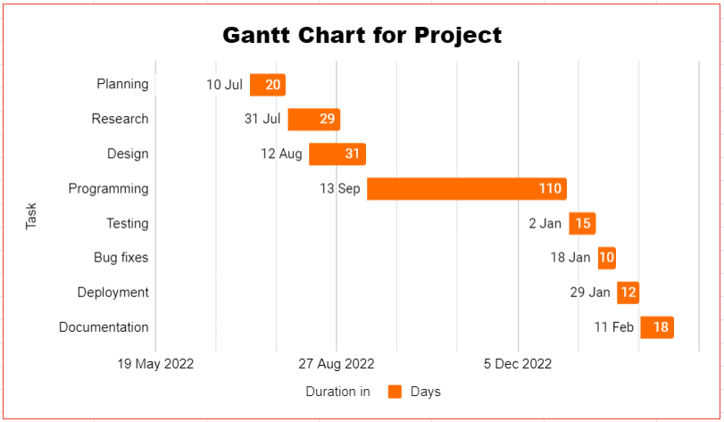

**3.5.3 Pert Chart**

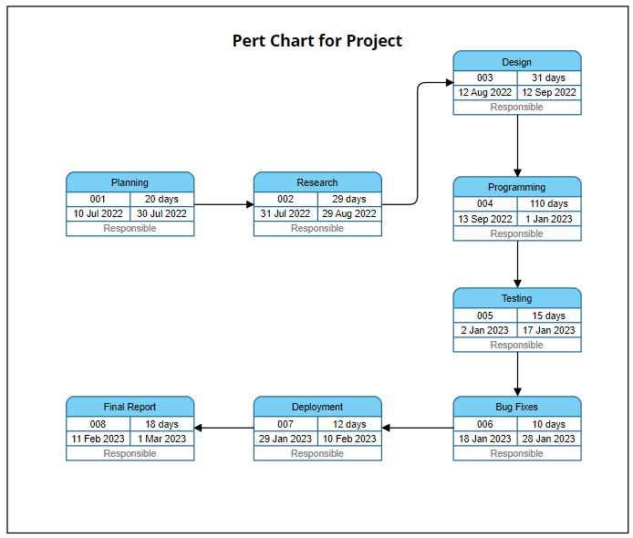

**3.6 Preliminary product description**

Crowdfunding platform helps us to quickly connect to a huge network of people by bringing campaign fundraising donors and organisers working together. The third party engagement comes with additional costs as most of the crowdfunding platforms are centralised. Blockchain has been used by numerous decentralised websites to provide peer-to-peer communication between the campaign organiser and the funder in order to solve this problem. Due to the benefits of blockchain, there is now a safe way for funders and campaigners to connect. Smart contract technology that makes it simple for campaigners to receive their funding after all requirements have been met. As a result, it makes it possible for donors to confidently support a project or cause that is free of fraud. Thus, by utilising blockchain in fundraising, we can alter the established method of raising money.

**3.7 Methodology**

The purpose of the system is to make the crowdfunding process transparent and secure. To accomplish this we are using ethereum blockchain, which is a distributed immutable ledger. We will keep the record of all transactions on this ledger. We will be using Next Js for frontend, solidity for writing smart contract and Web3 Js for combining frontend and backend.

**The system is composed of four modules:**

1. **Connect wallet:** It allows users to connect their crypto wallet for doing transactions. In blockchain transaction is not just transfer of cryptocurrency, it is transfer of data from one point to another. For doing any transaction you have to pay some amount of ether.
2. **Creating a Campaign:** Anyone can launch a campaign in a matter of minutes, A campaign can only be created after a few simple fields have been completed. The name of the campaign and a few phrases describing it must be provided by the campaign's author. The minimum donation amount and the campaign's target amount must be chosen by the campaign's author. The picture URL must be provided by the campaign's creator. Making a campaign-related graphic is ideal. Once the minimum contribution amount has been established, the contributor cannot make a contribution below it. The creator of the campaign must first connect their Ethereum wallet, which is the most important need. They won't be able to create a campaign if they don't have an Ethereum wallet or if they haven't connected their Ethereum wallet with Metamask.
3. **Contributing to a Campaign:** Users can share campaigns they have established, and after they have been created, anybody can contribute to them. Contributor is directed to the campaign contribution page when he clicks on a campaign from the main page. On that page, you can see the campaign's name and description, the minimum contribution amount the campaign creator set, the wallet address of the campaign creator, the number of requests that have already been granted, the number of approvers or contributors that have contributed to the campaign thus far, and the current status of the funds raised. The donor will not be able to contribute to the campaign if he does not use a meta mask to connect his ethereum wallet. The contributor can view the campaign withdrawal requests before making a contribution. The process will be more effective and anti-fraudulent because the monies would be paid to the campaign address rather than the campaign creator.
4. **Withdrawal of Funds:** By submitting a Withdrawal Request on the website, the campaign's creator can suggest how the money should be used. They must provide a good justification for the required sum. They need to enter the Ethereum wallet address. The approvers have the authority to review the request description and decide whether or not to approve the requested amounts. The approvers have the option to reject the request. Funds cannot be removed without approvers' approval. Once all approvers have approved and finalised, the desired amount can be paid into the recipient's wallet.

**3.8 Conceptual Model**

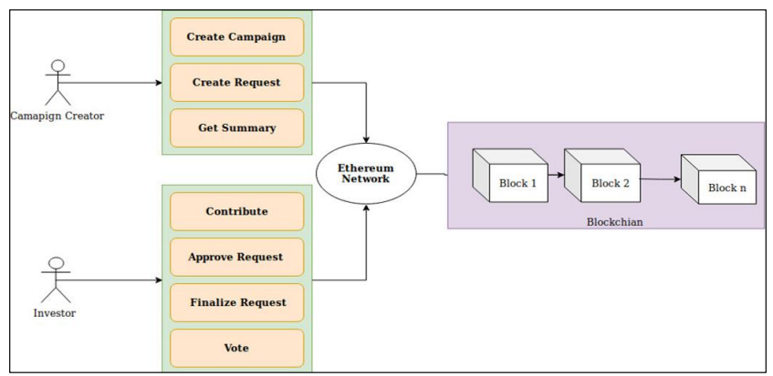

**Chapter 4 : UI Design**

**4.1 Flow of creating and contributing to campaigns**

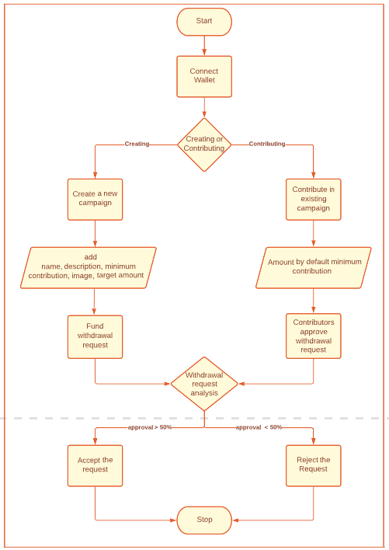

**4.2 ER Diagram**

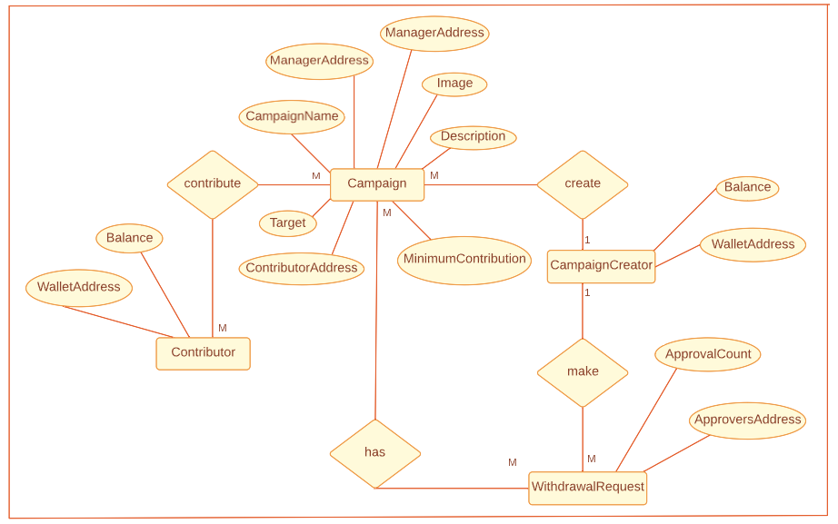

**4.3 Data Design**

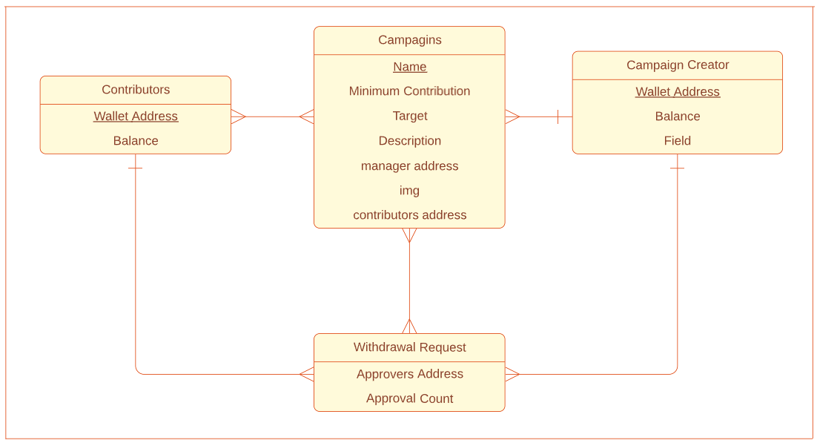

**4.4 Use Case Diagram**

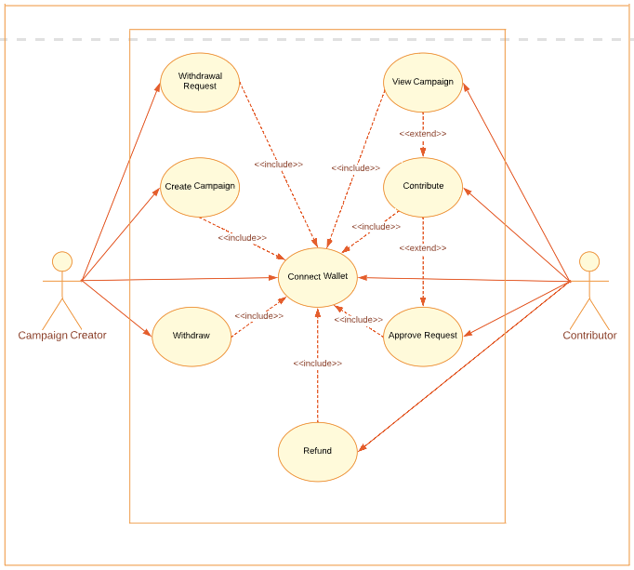

**4.5 Class Diagram**

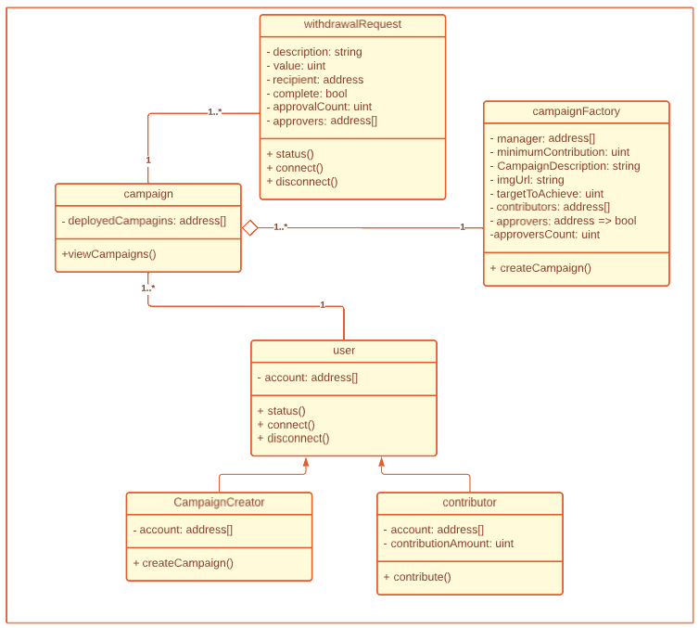

**4.6 Data Flow Diagram**

**4.6.1 Level 0 DFD**

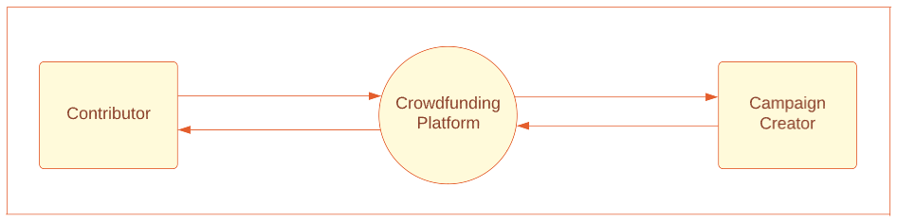

### 

### 4.6.2 Level 1 DFD

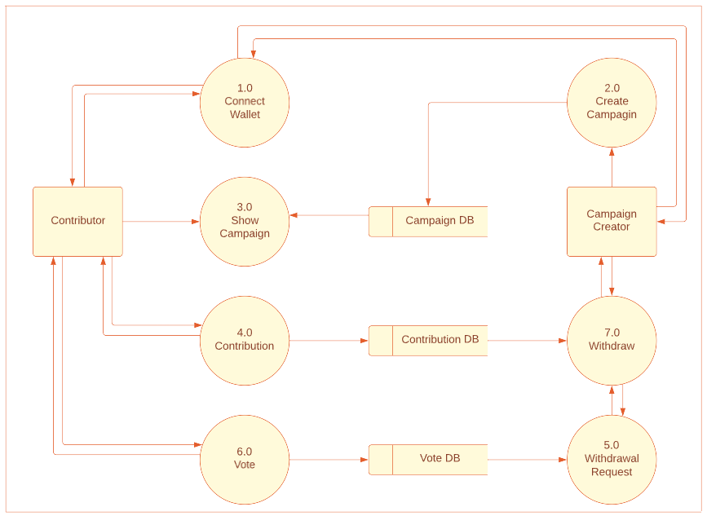

### 4.6.3 Level 2 DFD

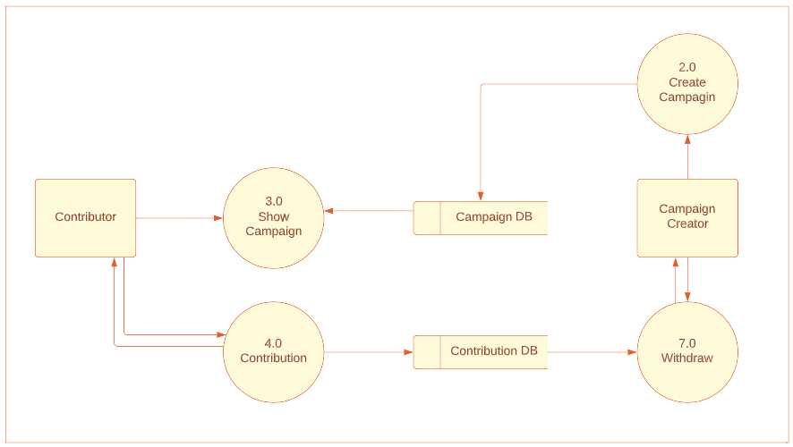

**4.7 Wireframes**

**4.7.1 Dashboard Page**

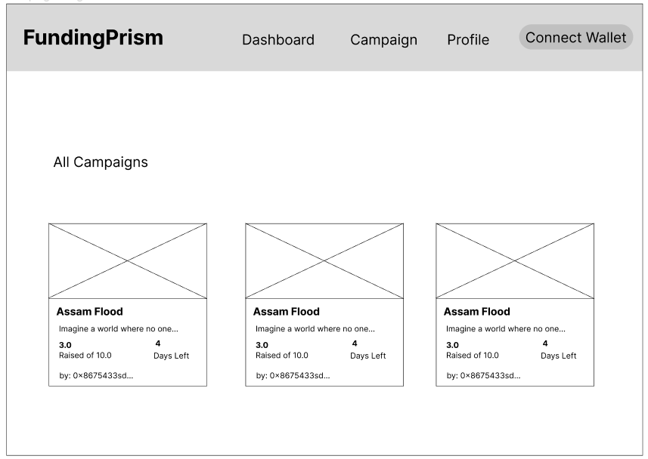

**4.7.2 Campaigns Page**

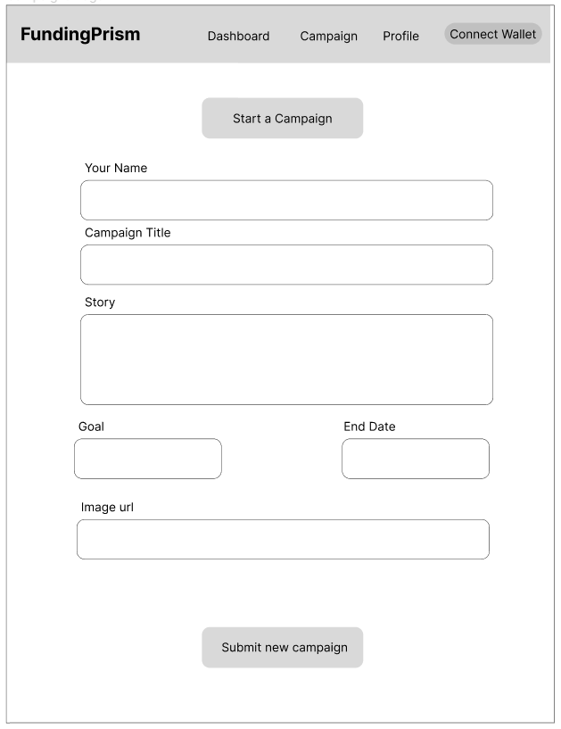

**4.7.3 Profile Page**

